 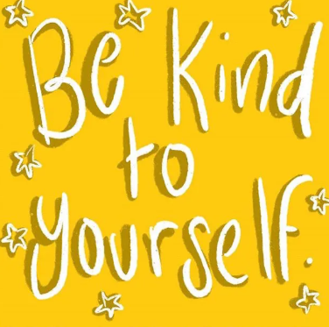

**Mental Health Awareness Week 18-24 May**

**Mental health problems can affect anyone, at any time.**

Mental health is the way we think and feel and our ability to deal with ups and downs. Mental health is something we all have. When we enjoy good mental health, we have a sense of purpose and direction, the energy to do the things we want to do, and the ability to deal with the challenges that happen in our lives.

**Talk about your feelings -** Talking about your feelings can help you maintain your mental health and deal with times when you feel troubled. Talking about your feelings isn’t a sign of weakness; it’s part of taking charge of your wellbeing and doing what you can to stay healthy. It can be hard to talk about feelings, but if you are open about how you feel, it might encourage others to do the same.

**Keep active -** Regular exercise can boost your self-esteem and can help you concentrate, sleep, and look and feel better. Exercising doesn’t just mean doing sport or going to the gym. Try to make physical activity that you enjoy as part of your day, even just a walk with your family – especially during this challenging time.

**Eat well -** What we eat can affect how we feel both immediately and in the longer term. A diet that is good for your physical health is also good for your mental health. It can be hard to keep up a healthy pattern during this difficult time, but regular meals are ideal. Mealtimes can be a time to come together as a family.

**Mental Health Awareness Week 18-24 May**

**Keep in touch -**  Being in a positive environment is hugely important for our mental health. Try and make sure you maintain your friendships and family relations even by having a chat on the telephone or face time at this difficult time. **Talking** is good and can often help.

**Ask for help *-*** None of us are superhuman. We all sometimes get tired or overwhelmed by how we feel or when things don’t go to plan. Don’t be afraid to talk to someone you can trust or rely on when you are not feeling quite yourself. Support each other, talking about mental health can seem daunting, but we’ve all had conversations that don’t always start easily but they often mean a lot to a person having a tough time. It all starts with asking someone how they are doing in a warm and authentic way – giving them a chance to realise that you are being sincere and friendly. Although remember, some people want peace and quiet – others like hustle and bustle.

**Listening -** just as vital as talking. Try and have eye contact, unless the person you are talking to doesn’t seem comfortable with that.  If it’s on the telephone, try not to interrupt, just listen.  When the conversation ends, recap what you have discussed and make sure you do what you say you will.

**Managing your own feelings -** It can be hard to hear difficult or upsetting things, but you want to reassure and encourage the person – that means not showing signs of surprise or judgement. You want to reassure the person that it’s OK to be speaking to you, and that you will treat what they say with respect. It is tempting to immediately start suggesting solutions to problems – but it’s wise to ask a person what they want to happen. They may welcome suggestions, but, equally, they may just need to vent.

**Mental Health Awareness Week 18-24 May**

**When you need to talk to someone who will understand you, when you are looking for advice to help a friend or family member, Kooth.com is here for you.**

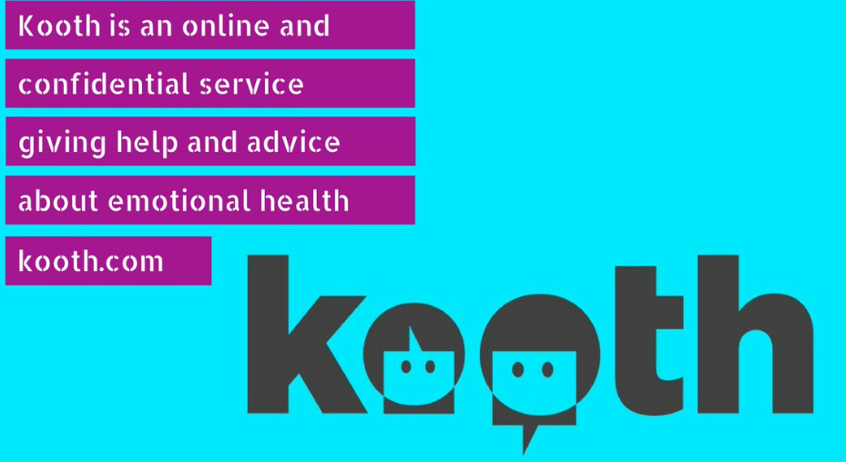

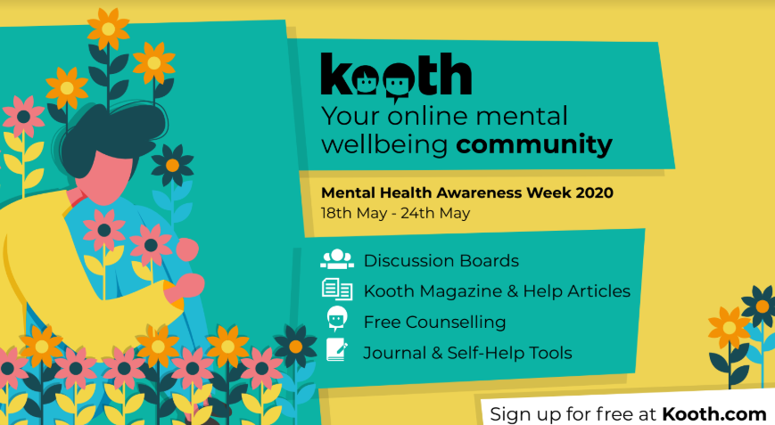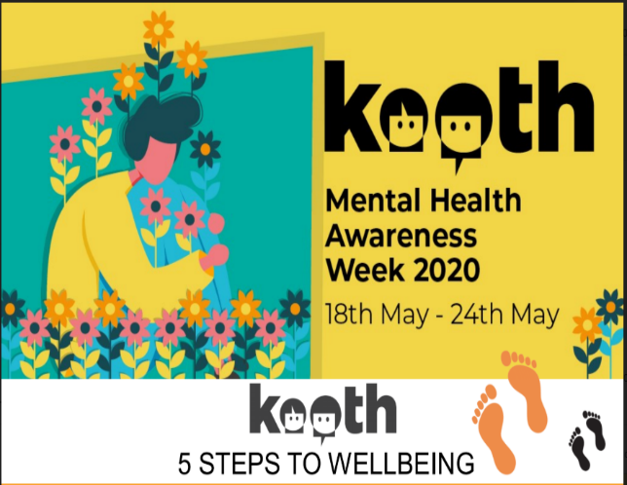

**../Downloads/Kooth Mental health awareness week_E poster.pdf**

**..\Downloads\Kooth 5 Steps to Wellbeing Interactive Activities.pdf**

**Mental Health Awareness Week 18-24 May**

**Who is up for a challenge?**



During this week, as **kindness** is our key word for Mental Health Awareness Week, I want to set you all a little challenge. It would be fantastic, if as many of you as possible could carry out and reflect on an **act of kindness**. Take a photo or video (with permission!) of yourself with a hat on (including staff) – try to make it funny so it can get us all smiling again and we can hopefully put all photos together and make a video to show we can all still smile and have fun when we come together and this difficult time. I will even do some mystery prizes for the best ones. Any hat will do, it could be a straw hat, woolly hat, cap, sun hat, swimming cap or you could even impress me by making your own. The choice is yours. Come on **St Mary’s** get your hats on!!!!!

Please send to: homestudyhelp@stmarysjarrow.co.uk

Mrs Colley

 