First Steps Nursery @ St Mary’s
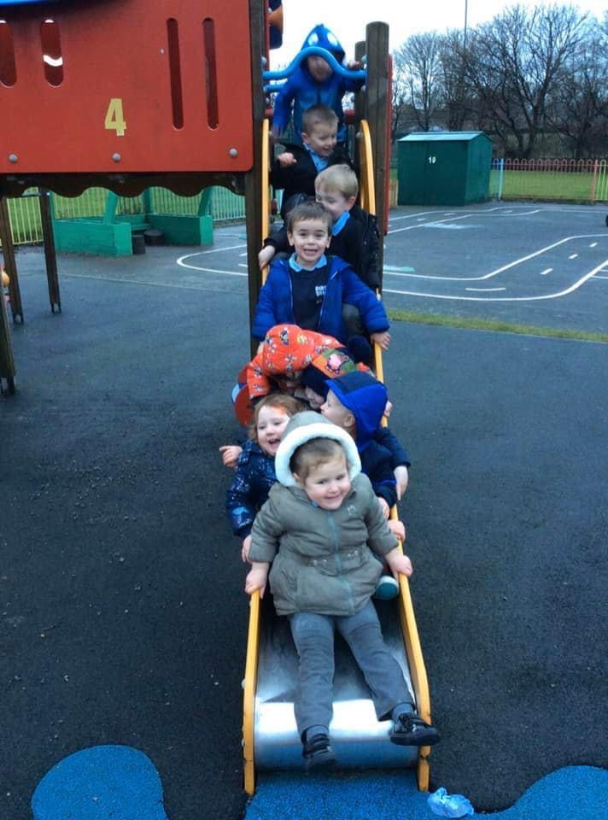

St Mary’s Catholic Primary School
Ayr drive, Jarrow
NE32 4AW
0191 4898336

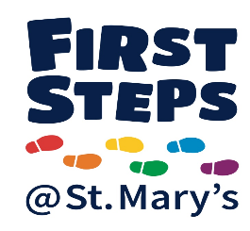
Welcome
Welcome
A very warm welcome to First Steps @ St Mary’s. We hope you and your child enjoy your time spent with us here in nursery.

Within our nursery we aim to provide a happy, safe, nurturing and stimulating environment for your child to grow and learn. We would like all of our children to reach their full potential and enjoy their time with us and we will support them in every way possible. We provide a wide range of activities and experiences for our children to learn and develop.

Our nursery is a very important part of St Mary’s Catholic School as many of our children go on to join the reception class in school. Please be aware you do not have to be part of the Catholic Faith to attend our school, so consider us when filling in school application forms.

Work, Play, Pray Together

The Sessions We Offer
Here at First Steps nursery we have 16 places for 2-year olds and 78 places for 3-4 year olds.

We currently offer half day and full day sessions. These can vary from 15 hour funded sessions, 30-hour sessions and privately paid sessions. Our nursery session times are:

Morning: 8:45am – 11:45am
Afternoon: 12:45pm – 3:30pm
Full day: 8:45am – 3:30pm

You can check eligibility for a 2-year funded place by visiting www.gov.uk/help-with-childcare-costs/free- childcare-2-year-olds

For any children accessing a 30-hour place, parents should provide their eligibility code, DOB & NI number as soon as possible, it is parents responsibility to keep these codes up to date however nursery staff will give you a little reminder when your new code is required.
Extra Sessions
Additional sessions are available should you require them at a small charge. Please see details below for pricing for each session. It is advised that you book required sessions however we will try and accommodate families wherever possible.

Session | Cost
Morning session (8:45 - 11:45am) | £15.00
Afternoon session (12:45 - 3:30pm) | £15.00
Packed Lunch | No charge
Wrap Around:  Breakfast  After school  Option 1: (3:30 - 4:30pm)  Option 2: (3:30 - 6pm)  Breakfast & After school | £3.00  £4.00  £7.50  £10.00

Please see a member of the nursery team to book your child in for extra sessions.

The Foundation Stage
The Nursery & Reception classes are referred to as the Foundation Stage of learning. This is an important stage, as it is during this time that attitudes to learning are formed and social skills develop, which lay out the foundations for future education.
A Unique Child | Positive Relationships | Enabling Environments | Children learn in different ways and at different rates
Every child is a unique, competent learner from birth who can be resilient, capable, confident and self-assured | Children learn to be strong and independent from a base of loving and secure relationships with parents and/or a key person | The environment plays a key role in supporting and extending children’s development and learning | The EYFS Framework covers the education and care of all children in early years provision, including children with special educational needs and disabilities

Young children learn most effectively through a balance of structured and child-initiated play. Our team work together to plan for the children’s learning to ensure that all areas of development are covered within an interesting, stimulating and supportive framework.
Early Years Foundation Stage
The EYFS curriculum is still based around seven areas of learning and development.

There are three Prime Areas:
- Communication & Language
- Personal, Social & Emotional Development
- Physical Development

These areas cover the knowledge and skills required to form the foundations of formal learning. The Prime Areas develop through effective relationships and experiences, supporting learning in all other areas, and remain fundamental throughout the EYFS.

There are four Specific Areas of learning and development which grow from the Prime Areas and provide important opportunities for extending knowledge:
- Literacy
- Mathematics
- Understanding the world
- Expressive Arts & Design

Our 2 Year old room.
In our 2-year-old room we offer a wide range of age appropriate activities and endless opportunities to support and develop all areas of learning
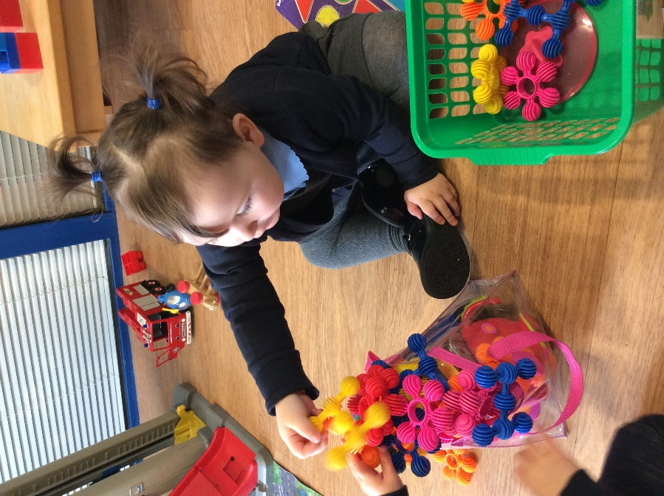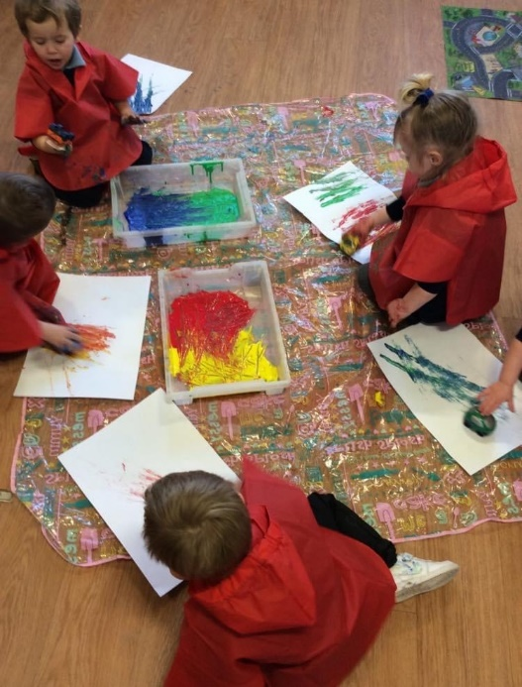

We promote independence with our children throughout when in nursery by encouraging them to make their own choices, washing hands for snack, when using the bathroom and putting on their own coats for outdoor play, staff are always there to help and support when needed.

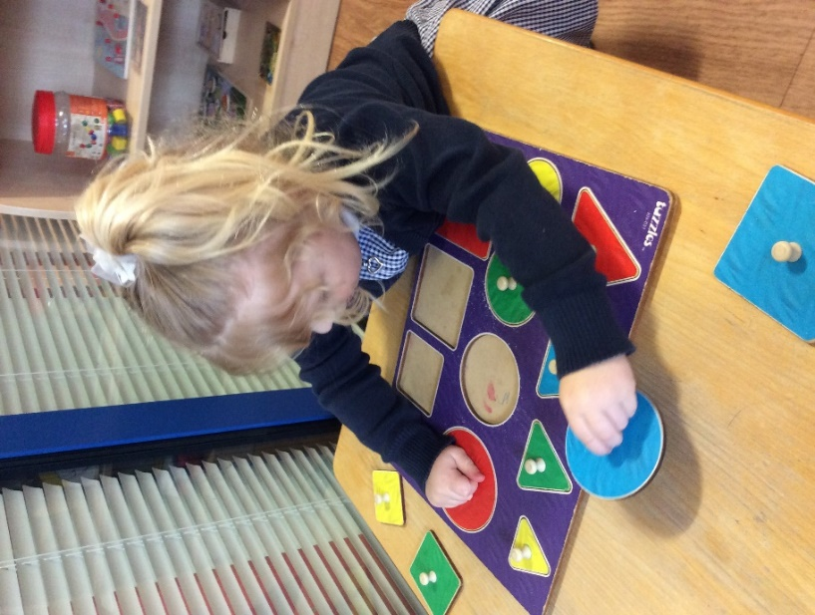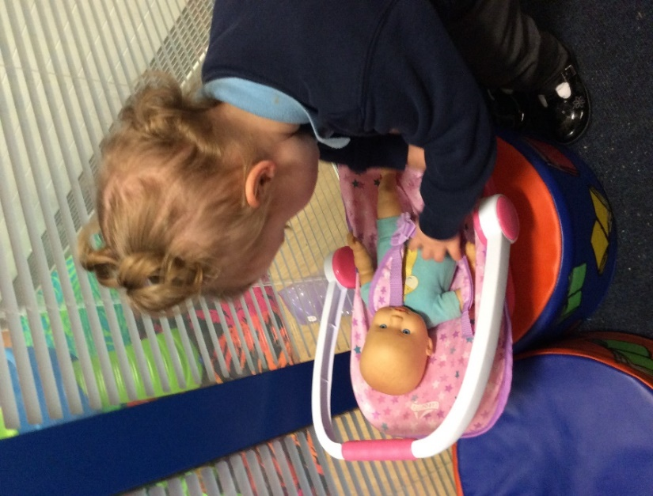

We observe and record our children’s progress and development. We follow the children’s interests and provide opportunities to expand on these interests through their daily play.

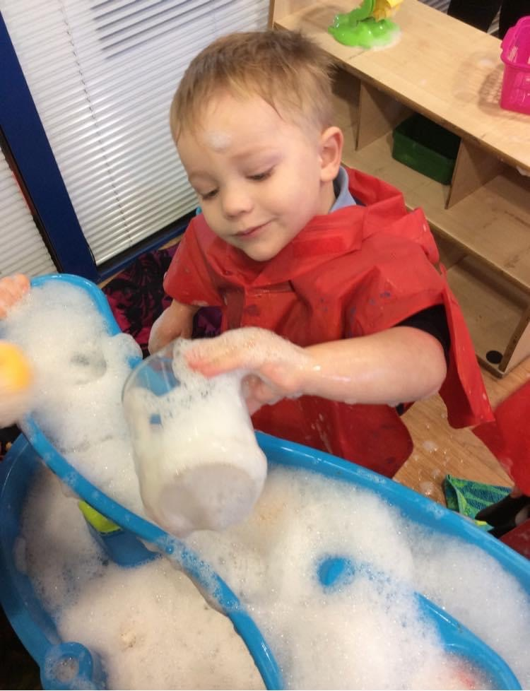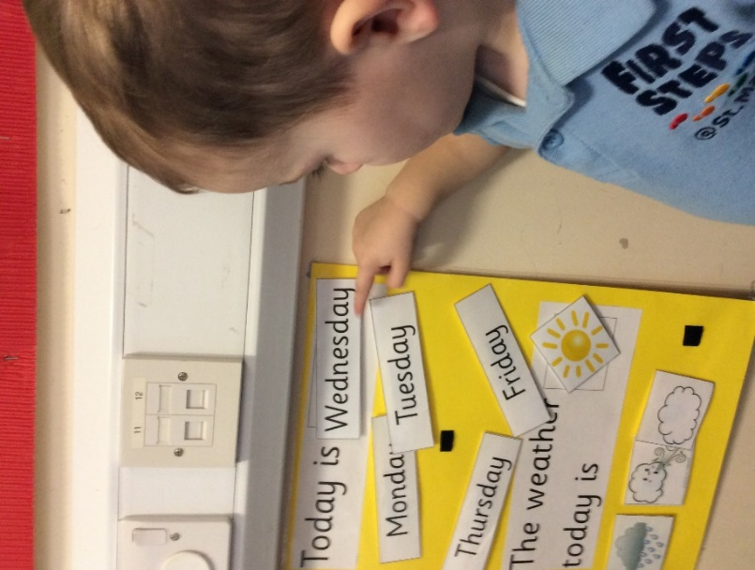
Daily Routine
Our daily routine in the 2-year-old room is as follows:
Morning:
08:45 – 09:00 Free play as the children arrive
09:00 – 09:15 Registration & Welcome time
09:15 – 10:15 Free play
10:15 – 10:30 Small group time
10:30 – 11:00 Outdoor play
11:00 – 11:20 Wash hands/Snack time
11:20 – 11:45 Nursery rhymes, action songs, re-call
Afternoon:
12:45 – 01:00 Free play as the children arrive
01:00 – 01:15 Registration & Welcome time
01:15 – 02:15 Free play
02:15 – 02:30 Small group time
02:30 – 03:00 Outdoor play
03:00 – 03:15 Wash hands/Snack time
03:15 – 03:30 Nursery rhymes, action songs, re-call
Our 3 year old room
The children have access to lots of different areas within our 3-year-old room: role play area, reading area, creative & messy play, water play, playdough area, writing area, small world and construction area. All with opportunities to support and develop their interests and learning.

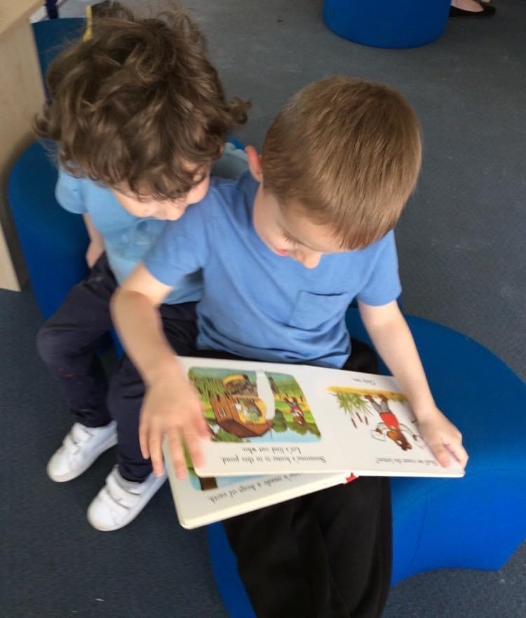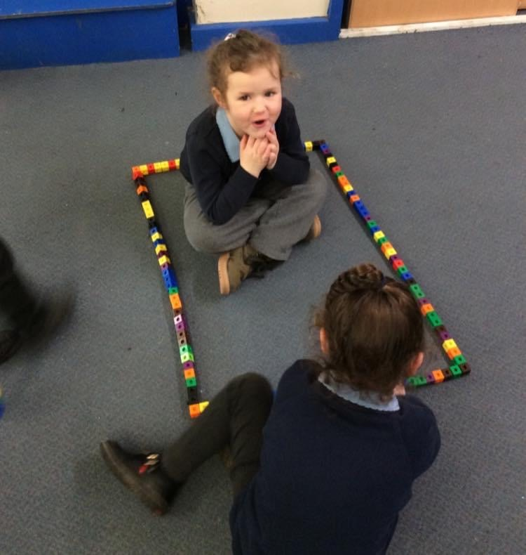

The children’s interests are recorded and activities are planned for the children based on these, encouraging and supporting all areas of development.
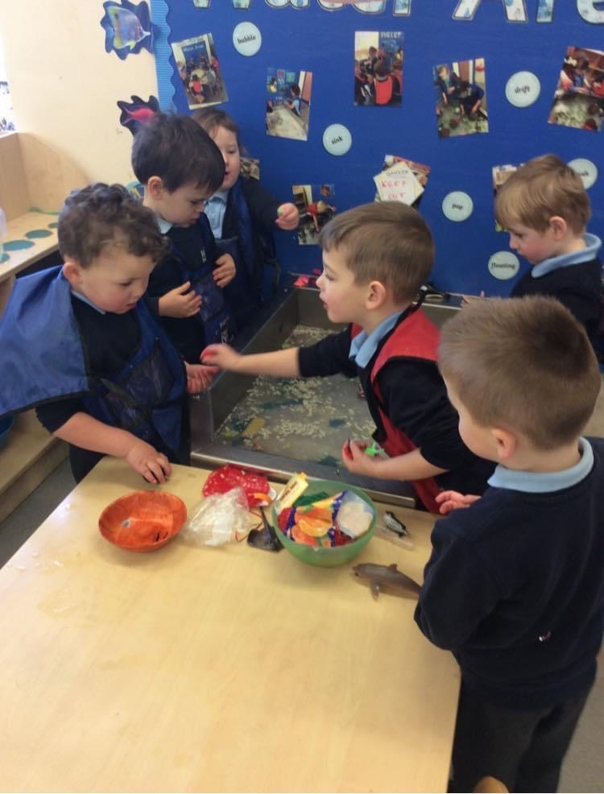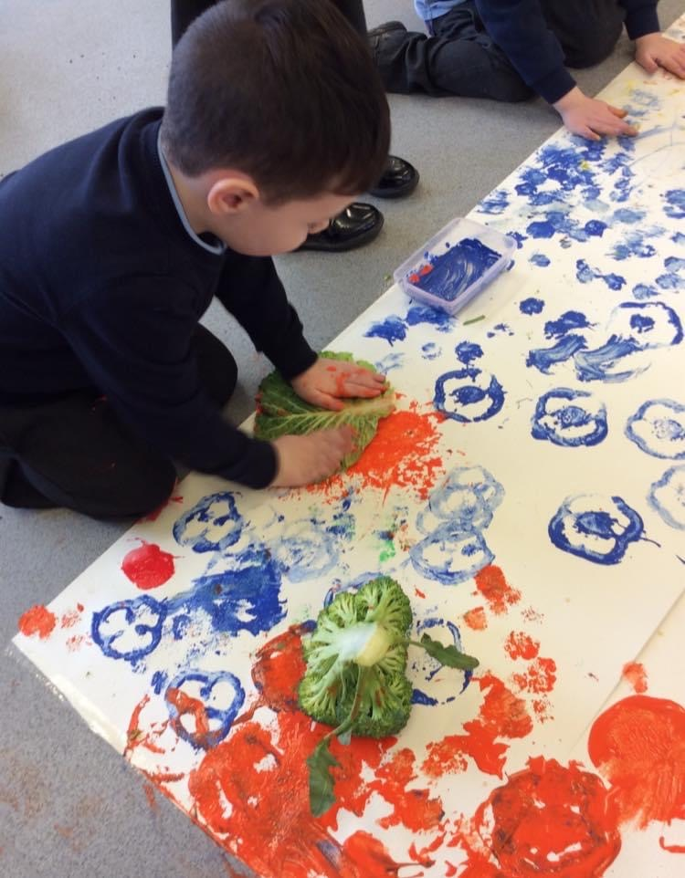

The children are given a wide range of opportunities to engage in lots of various activities when in nursery. Together they share experiences, helping and supporting each other to achieve their chosen goal with various activities.

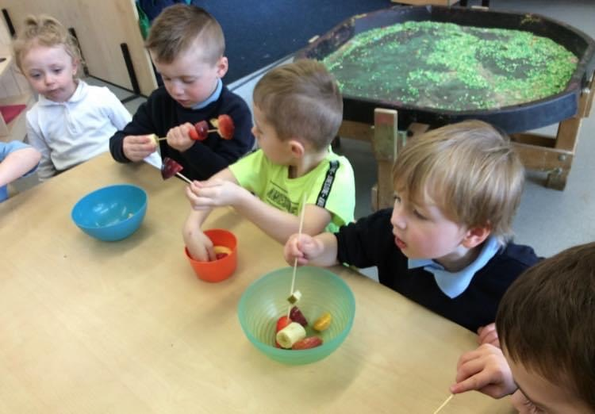

Daily Routine
Our daily routine in the 3-year-old room is as follows:
Morning:
08:45 – 09:00 Wake up, Shake up
09:00 – 09:15 Registration/Bagels/Small group
09:15 – 10:15 Free play
10:15 – 10:30 Wash hands/Snack time/Phonics
10:30 – 11:30 Outdoor play
11:30 – 11:45 Story time
11:45 Lunch time

Afternoon:
12:45 – 01:00 Wake up, Shake up
01:00 – 01:15 Registration/Small group
01:15 – 02:00 Free play
02:00 – 02:15 Wash hands/Snack time/Phonics
02:15 – 03:15 Outdoor play
03:15 – 03:30 Story time

Our Nursery Garden
We are very fortunate to have a lovely big outdoor space for the children to play and explore. We have our very own play equipment, with a slide, swings & climbing frame, all supporting our children’s physical development. We also have a big yard where the children can play on bikes and scooters or simply just play.
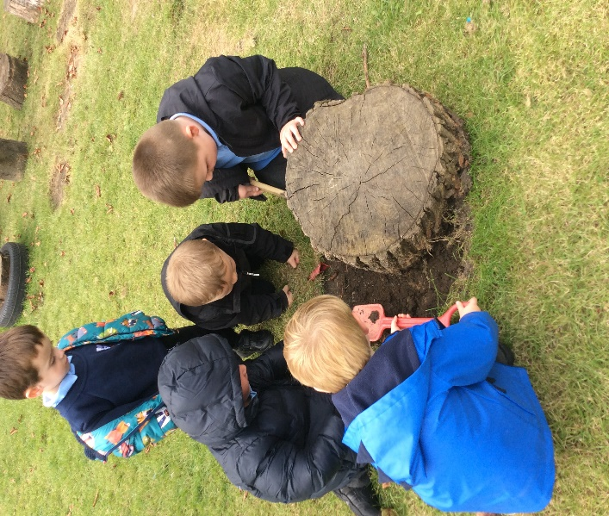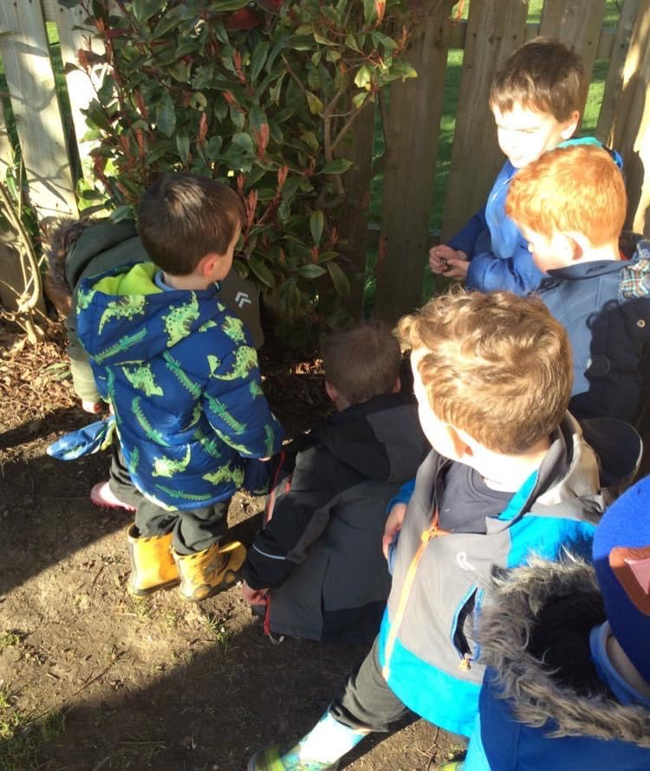

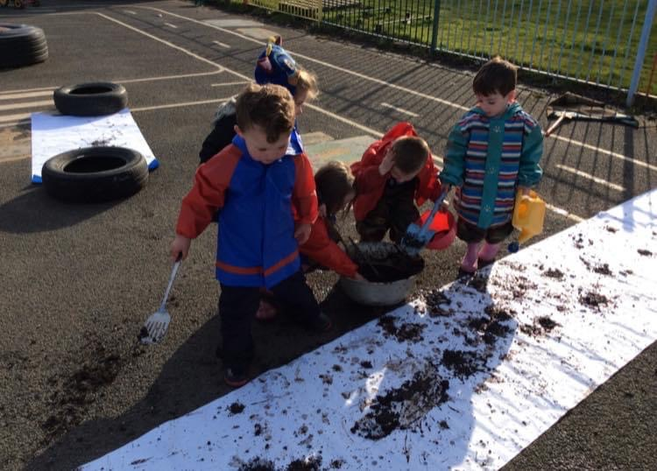
Our children have endless opportunities outdoors. Mud kitchen, water, gravel and diggers are just some of the things they can play with. The children use their own imagination when outside and we explore together.

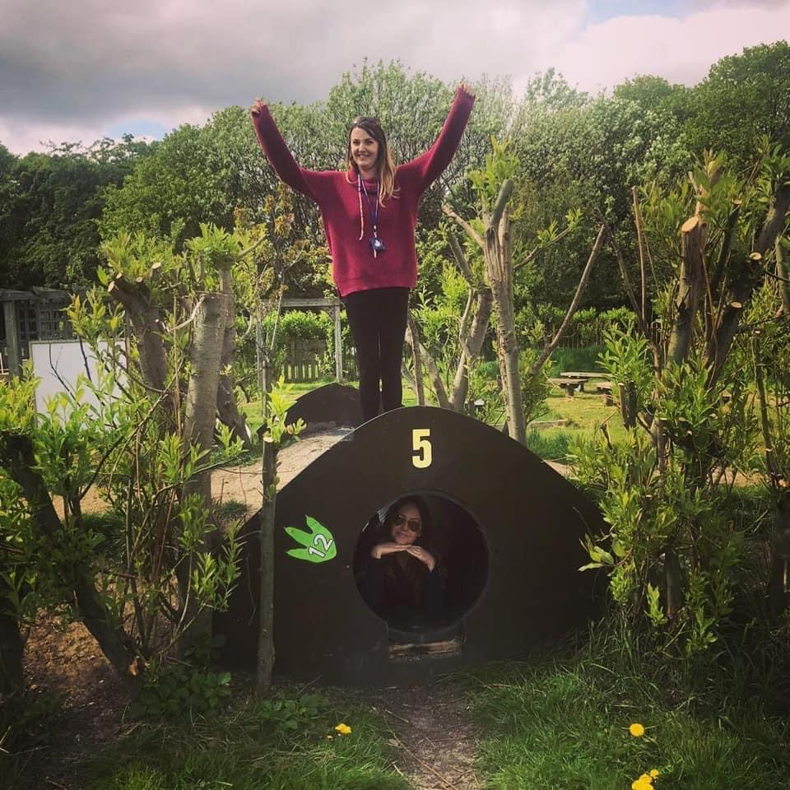

We also have our own allotment in the nursery garden where we encourage our children to grow their own fruit and vegetables. Allowing them to take care of them and watch them grow. Once the produce is ready, we carry out cooking activities, food tasting or share with parents to take home.
Tapestry
We use Tapestry within our nursery setting to share photos between nursery and home. It is a lovely way to share experiences.

You will be given a form on your child’s initial visit to complete. We ask that you provide an email address and we will send you the link. Once you activate the link you, you will have access to all photos that staff post and you can add photos to show us what your child has been doing at home.

Class Dojo
We also use the ‘Class Dojo’ app to send out messages and letters. After you have completed your contact information, you will receive a text explaining how to access your account.

Admissions
Once your child’s place has been confirmed by a member of our team you will be invited in for an initial visit. This visit will be used to complete all the relevant paper work, have a look around the nursery and meet our team. This visit can last anything from half an hour to an hour.
You will then be given a date to return for your child’s next visit, during which you can leave your child should you feel comfortable doing so, if not we can provide a place to sit whilst your child plays in the nursery room.
We take the lead from the child with further visits as all children are different, some will run in to the room on their first visit and then happily start, where some will need more visits to settle if they are a little upset or anxious about leaving parents/carers.
Please do not worry if your child is upset, we can arrange as many visits as they need. We completely understand that it is a difficult time for parents to see their children upset on visits and we will support you and your child through this transition.

First Day at Nursery
On your child’s first day at nursery we ask that you bring the following to keep on your child’s coat peg or in their tray:

- Nappies & wipes if required

- A change of clothes
(A full outfit if possible, as spare clothes in nursery is very limited)

- A comforter if required

We do not encourage children to bring dummies, blankets and toys into nursery in case they go missing, however if your child is upset and feel this will settle them, you can bring a comforter on their first day.

Uniform
Although it is not compulsory to wear a uniform in nursery some families do choose to do so. Should you wish to purchase uniform please contact ‘Initial Images’ who will be more than happy to help.

2D&E Rekendyke
Eldon Street
South Shields
Tyne & Wear
NE33 5BZ
0191 4558128

The children have access to messy play throughout their session and are encouraged to explore the outdoors, we do encourage children to wear aprons during messy activities, however we do recommend you do not put your child’s nice clothes on them for nursery.
Parent Partnership
We have an open-door policy in nursery and it is important to us that parents/carers feel welcome and that they can communicate any queries or concerns they may have.
We try to involve parents/carers as much as we can in nursery. We hold termly Stay & Play sessions where you are invited into the nursery room to play with your child and discuss their development.
We also have a weekly library day, every Wednesday where you can come in and share stories with your child.
Throughout the year we also have various celebrations and events during which we ask for parental involvement, one of our favourites is our ‘Teddy Bears Picnic Garden Party’, the children, staff and parents all have a lovely day. We look forward to you joining in with these experiences with us, making memories with your child.

Toddler Group
Our nursery Toddler Group takes place every Tuesday, 1pm - 3pm. There is a small charge of 50p per child, all funds raised go towards toddler group resources
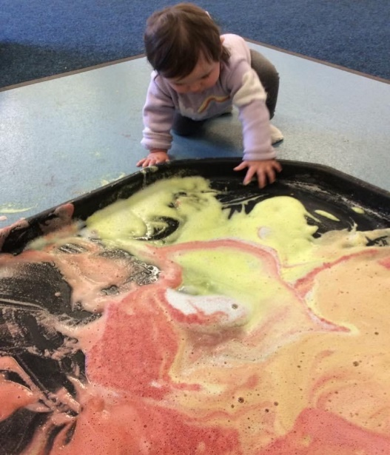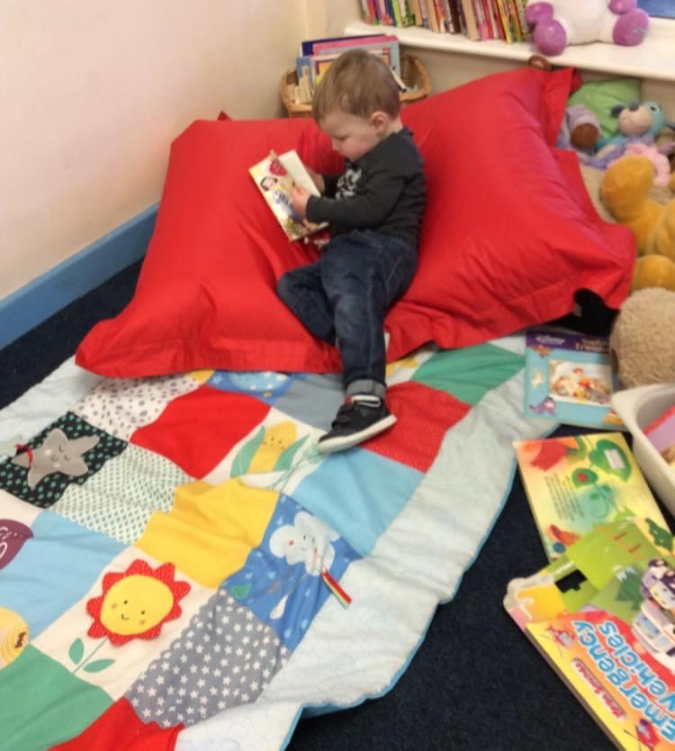
We have a wide range of toys and activities for the children to explore. Suitable from birth to 3 years old. Miss Lowes also ends the session with a sing song. It is a lovely social experience for children and parents/carers.
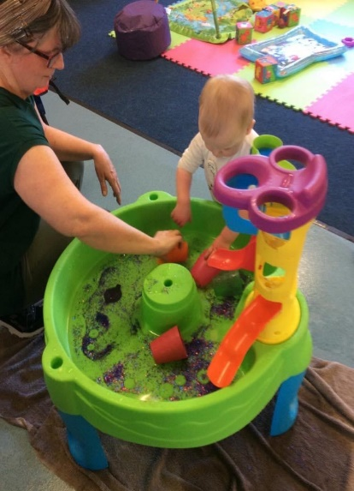
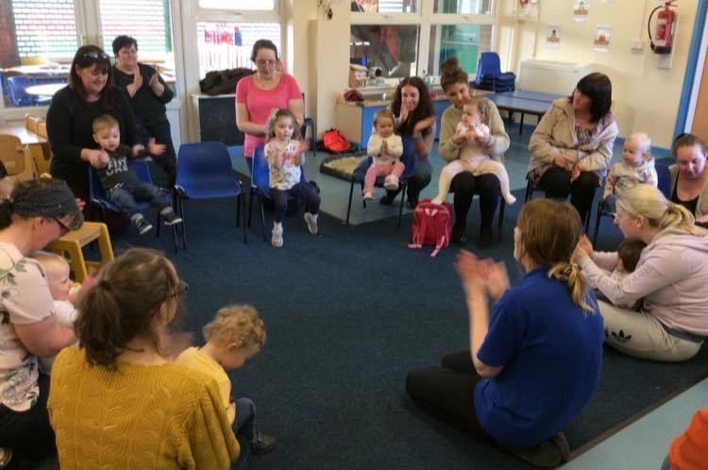
Healthy Eating
The children are offered health snacks during their nursery sessions, morning and afternoon. We provide a drink of milk or water (we only allow juice at lunch time) and a selection of fresh fruit and vegetables.

If you are providing a packed lunch for your child’s dinner, we do encourage health choices and ask parents not to put sweets or chocolate in their packed lunch bag where possible.

Behaviour Management
We encourage good behaviour with all children in nursery. We encourage them to respect themselves, each other, adults and nursery property. We apply some simple rules fairly and consistently throughout their session. Should a child display unacceptable behaviour regularly, this will be discussed with parents/carers. We will put strategies in place to help and support the child in nursery and at home if needed.

- We have kind hands and feet.
- We listen to others.
- We take turns and share.
- We walk indoors.
- We help to keep our nursery tidy.

Special Educational Needs (SEN)
We track our children’s progress regularly which helps us with early identification of children’s individual needs. We work closely with parents/carers to develop effective strategies and development plans to support the child. We also work closely with outside agencies and professionals to ensure the best support possible for the family.

Contact details
We ask that all parents/carers keep contact details up to date, if you change your telephone number or address please let us know. Please ensure that we have at least one Emergency Contact up to date at all times too. Staff administer first aid and report incidents to parents upon collection, however if there is a more serious matter regarding your child, we may need to contact you or a relative. It is vital that these details are kept up to date in nursery.

Collecting Children
We have a collection policy by which if someone different is collecting your child whom staff have not met before we will ask for you to arrange a password which they will be asked for when they collect your child.
Should someone come to collect your child who we have not met or been informed about, we will not allow them to take your child. You will receive a telephone call from nursery to ask if this person can collect your child. Safeguarding our children is paramount.
Jewellery
We have a NO jewellery policy in nursery. We ask that for the safety of your child that you do not allow them to wear any jewellery for nursery.

Toilet Training
Children do not have to be toilet trained before coming into nursery. When the time comes to toilet train your child, we will work closely with you and your child to support them using the potty or toilet. We encourage all of our children to be independent when in nursery when using the bathroom and washing their hands.
We ask that you provide multiple changes of clothes and a change of shoes on a daily basis if your child is toilet training as we can have a few accidents to begin with as they are learning.
Please speak to a member of staff if you need any help or advice on starting to toilet train your child.

Childhood Illnesses
As you are aware children do become poorly from time to time. We do have sickness policies in place within nursery and for some childhood illnesses we do have an exclusion period. Please see the details below for some of the more common illnesses.
Childhood Illness | Children can return
Sickness & Diarrhoea | 48hrs after the last episode
Conjunctivitis | 24 hrs after starting drops
Slapped Cheek | Not infectious once the rash appears
Chicken Pox | Until spots scab over

We do ask that if your child is showing signs of being unwell and you feel they will not benefit from their nursery session, then please keep them at home until well enough to return. If your child is poorly, please ring and leave a message on the nursery answer machine.
School Readiness
We know it can be very daunting time for yourselves when you have to consider ‘big school’ for your little one. We are here to support you and your child throughout.

Nursery will provide parents/carers with school admission forms when the time comes and we are here to help complete forms, discuss concerns and choices should you need us.

Getting our children school ready is very important to us. Helping them build those skills they need to take the big step into Reception.

We work closely with all schools in the area to pass on any relevant information with regards to children should they be joining their school. As we liaise with each other to make sure transition is as smooth as possible for you and your child.

Keeping you up to date
We like to keep you all up to date with important information and about things we have planned, we hand out newsletters to parents and display information on the screen located in the foyer of our nursery so please look out for any information.

We do have our own Facebook page where we like to share photos of the children so you can see what they have been doing in nursery and again reminders of important dates coming up so please like our page.

We are currently in the process of designing our own website, we will give further details once it is complete.

The nursery team would like to take this opportunity to thank you for choosing First Steps Nursery for your child.
We hope you enjoy your time with us!

“I am in nursery, I’m not built to sit still, keep my hands to myself, take turns, be patient, stand in line, or keep quiet all of the time. I need: motion, novelty, adventure and to engage the world with my whole body. Let me play.”

