Dear parents and carers,

Welcome back to the Spring term here in First Steps Nursery. This half term our topic is ‘Amazing animals’, during which we will be learning about animals from around the world, including cold places like Antarctica or jungle animals from very hot countries such as Africa. Some key books covered this term will include ‘Polar bear, polar bear, what do you hear’, ‘Dear Zoo’, ‘Brown bear, brown bear, what do you see’ and ‘The snail and the whale’.

The children will be involved in discussions about the names of animals that live in these different climates, will talk about their body parts, how they move and where they live. We will listen to animal sounds, learn songs about animals and celebrate Chinese New Year, which this year is the year of the snake. Later in the term we plan to invite Emma’s exotic animal encounters into Nursery so that children to experience and handle live animals such as parrots, snakes, owls, frogs and chameleons to name but a few. We will keep you all posted so please check face book and our school website for photos and updates.

We will have a large focus on discussing stories this term and will have a focus book to discuss each week which will be shared via Dojo. The children will be helping to retell stories, describing events and characters and joining in with the words and patterns in repetitive stories at small group time. We will also be having a big push on mark making and writing as the children move through the school year in readiness for school. We will be drawing pictures of our family experiences, animals and beginning to represent our name with letter shapes. You can help your child at home by modelling drawing simple shapes and objects to them or ensuring that they are holding their pencil correctly to draw and write.

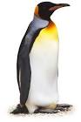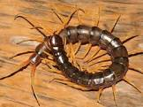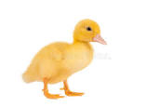

At present, we are developing our role play area as the children have really been enjoyed baby play recently and we want this area to reflect their home environments more. We would really appreciate donations of any of the following item:
Dolls clothes
Baby blankets / towels.
Kitchen utensils
Empty baby milk tins
Baby Moses basket
Toy rattles / baby brush

As always, Nursery is a messy place and your child will often need to be changed during the day. Please ensure that your child has a bag of clothes on their peg including several sets of underwear and socks and skirt or trousers in order that they can be changed by staff if necessary. We are very low in stock of underwear socks if you have any to donate at home for spares. If your child requires nappies or wipes please also send these into Nursery in a labelled bag.Please make sure that all clothing, especially jumpers or cardigans are clearly labelled with your child’s name.

If you have any concerns or queries please see a member of nursery staff at pick up or drop off.

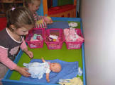
Yours Sincerely,
Mrs. Walker and the Nursery team.

